From: Michael J. Augustine, President/CEO
Frontier Community Credit Union

RE: The Credit Union Difference March 1, 2021
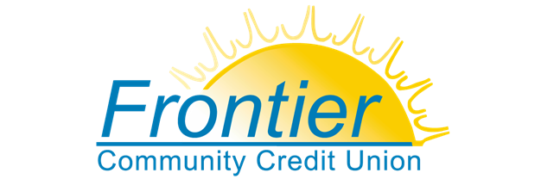
Dear Members,
By joining Frontier Community Credit Union, you made the smart choice to protect your family's financial future.
Because were not-for-profit and owned by our members like you, credit unions are tax exempt, and we make decisions based on what is best for our members. We don't answer to Wall Street investors or worry about generating returns for stockholders. During the COVID-19 crisis we’ve been able to provide assistance to our members in many ways. Assisting in loan relief, waiving penalties on early CD withdrawals, offering SBA Paycheck Protection Program loans, and providing financial education resources for students, parents and teachers are just a few examples.
Now that we have a new Congress and President, we must ensure credit unions stay top-of-mind for lawmakers in Washington, D.C., and in our state legislatures. We need to make sure they hear from us, to tell them about the credit union difference! Credit unions are a consumer’s safest and best option for quality financial services and invest in our local economies to help build our middle class. You can learn more about the credit union difference here.
Check our website periodically to hear the latest on important issues facing credit union members. Civic engagement has always played a critical role in making our democracy work. It’s up to all of us to make our voices heard.
Thank you for being a member of Frontier Community Credit Union. Take your membership to the next level by letting our elected officials know how much your credit union means to you and your family.
Find out how to be more involved here.
As one of 120 million credit union members across the country, your opinion matters!

Sincerely,
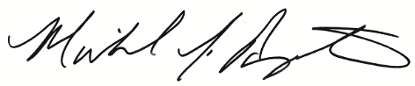
Michael J. Augustine
President/CEO

